**In this competition, students learn to navigate EU Regulations and international treaties that apply across multiple jurisdictions and require uniform interpretation.**

# The Moot Court comprises two phases, a written phase and an oral phase.

The teams are presented with a case focused on Private International Law issues (such as jurisdiction, choice of law or recognition and enforcement), and students gain first-hand experience in understanding and applying the complexities and nuances of how international conventions and EU Regulations interact in the context of transnational litigation.

Private International Law is the set of legal principles and rules that determines the applicable law in international civil and commercial cases, allocates jurisdiction, and regulates the recognition and enforcement of foreign judgments.

This field of law often lies at the heart of significant multinational legal disputes, where in certain instances the entire case hinges on which court has jurisdiction, which law applies or the cross-border effects of judgments.

In the oral phase, teams plead before renowned judges, academics, and practicing lawyers in Private International Law.

# PAX Moot Court

2026

The next edition of the PAX Moot Court closes with oral rounds that take place in Sofia in 2026. For a sneak peek of the 2026 edition click [**here**](https://www.paxmoot.eu/video). More information on the Rules and Procedures of the competition can be found on the PAX [**website**](http://www.paxmoot.eu/).

Funded by the European Union. Views and opinions expressed are however those of the author(s) only and do not necessarily reflect those of the European Union or the European Commission. Neither the European Union nor the granting authority can be held responsible for them.

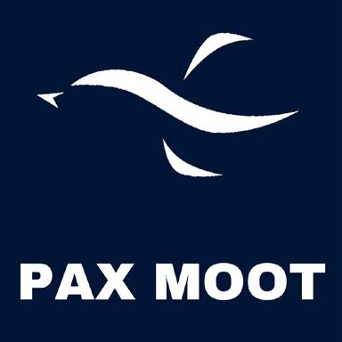

PAX Moot Court is an international mooting competition focused on **Transnational Private International Law**.